**GOOGLE DRIVE MANAGER**

**Group Members:**

118A3020-Suraj Iyer

118A3034-Saara Parkar

**Description:**

A Google drive manager to view, upload, remove or regularly backup files or folders to google drive from the terminal. The user is provided with a menu driven program to carry out any of the above operations. The user just needs to enter the file or folder path name

(also the time of daily backup in case of enabling regular backup) as input. The backup option schedules a daily backup for the file or folder at the time entered by the user.

It uses a tool called google-drive-ocamlfuse, which upon configuration, clones files and folders present on google drive into a local directory.

**Steps for demonstration:**

**Step 1: Installation and configuration**

Following are the steps for installation and configuration of this google-drive-ocamlfuse:

1. Install google-drive-ocamlfuse using the following commands:

*sudo add-apt-repository ppa:alessandro-strada/ppa*

*sudo apt-get update*

*sudo apt-get install google-drive-ocamlfuse*

1. In order to configure it with your google account, run the command without any parameters:

*google-drive-ocamlfuse*

This command will create the default application directory (~/.gdfuse/default), containing the configuration file config. And it will start a web browser to obtain authorization to access your Google Drive.

1. Then you can choose a local directory to mount your Google Drive (e.g.: ~/google-drive).

*google-drive-ocamlfuse ~/google-drive*

**Step 2:Execution of shell script**

1. Run the following command to allow everyone to read and execute the shell script:

*chmod +x gdm.sh*

1. Execute the shell script by typing the command:

*./gdm.sh or sh gdm.sh*

1. Once the shell script is executed, a menu appears as shown:

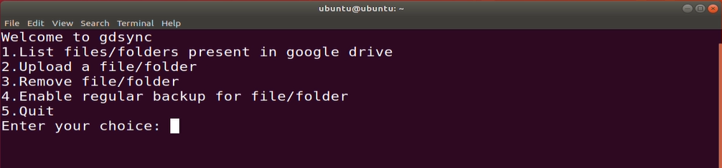

1. Choose the option to as per requirement and enter the file or folder path name.
2. The program will then carry out the operation based on the choice provided. In case of option 4, a cronjob is added to the crontab based on the time provided by the user that carries out a backup for the given file or folder daily.

**Code:**

*#!/bin/bash*

*function gdsync() {*

*while :*

*do*

*clear*

*echo "Welcome to gdsync"*

*echo "1.List files/folders present in google drive"*

*echo "2.Upload a file/folder"*

*echo "3.Remove file/folder"*

*echo "4.Enable regular backup for file/folder"*

*echo "5.Quit"*

*read -p "Enter your choice: " usr_cmd*

*clear*

*case $usr_cmd in*

*1)echo "Files/Folders in Google Drive:"*

*tree google-drive*

*;;*

*2)read -p "Enter file/folder name to be uploaded: " upname*

*cp -r $upname google-drive*

*echo "Upload Successful"*

*;;*

*3)read -p "Enter file/folder name to be removed: " remname*

*find ./google-drive -name $remname -exec rm -r {} +*

*echo "Removed Successfully"*

*;;*

*4)read -p "Enter file/folder name to enable backup: " fname*

*read -p "Enter the time for daily backup (HH MM): " hour min*

*echo "$min $hour * * * find ./google-drive -name $fname -exec rm -r {} +; cp -r $fname google-drive">>mycrontab*

*crontab mycrontab*

*rm mycrontab*

*echo "Backup successfully enabled !"*

*;;*

*5)break;;*

*\*)echo "invalid option";;*

*esac;*

*read -p "Press 5 to quit,anything else to return to main menu " confirm_exit*

*if [ $confirm_exit -eq 5]*

*then break*

*fi*

*done*

*}*

**Output:**

View:

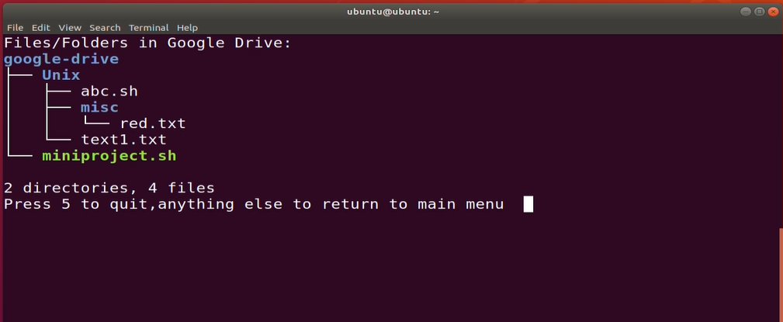

Upload:

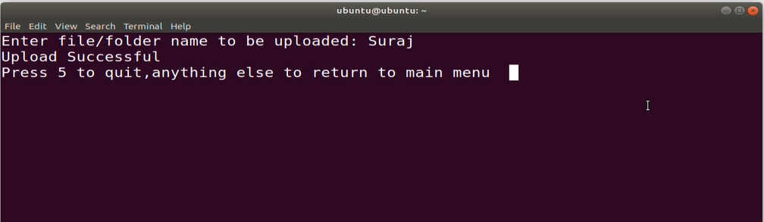

Remove:

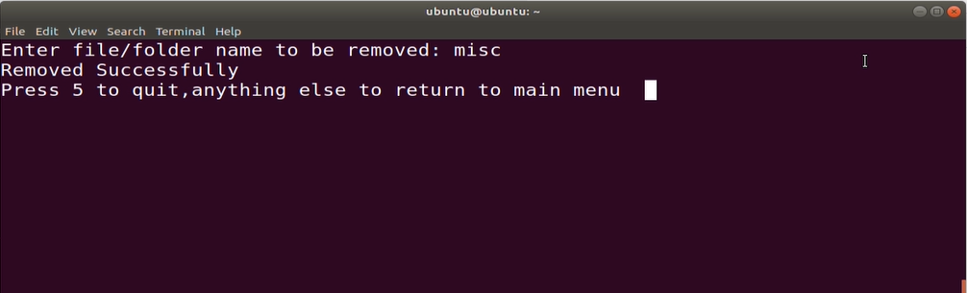

Backup:

